PRESS RELEASE

BELLE DE JOUR AT 20: EVOLVING INTO BIG DREAMS JOURNEY
Where small steps turn dreams into a life fully lived.
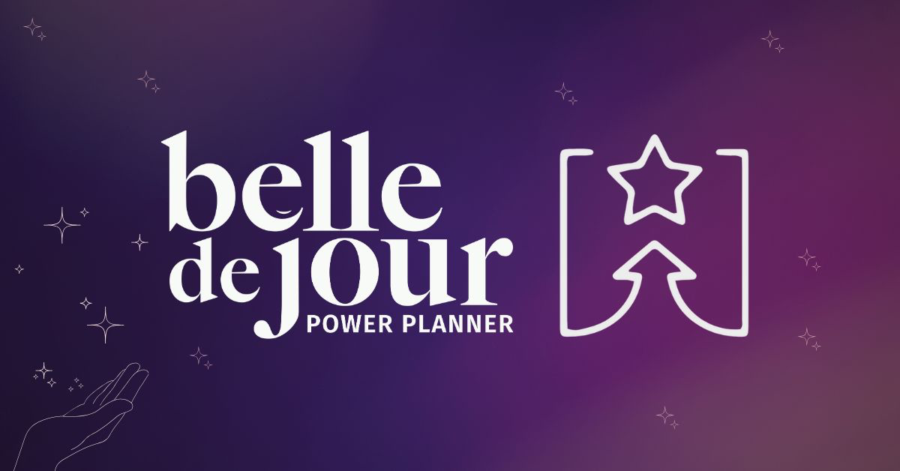
Manila, Philippines – For twenty years, the Belle de Jour (BDJ) Power Planner has been more than a productivity tool. It’s been a confidante, a mirror of aspirations, and a map for countless dreamers finding their way.
As the iconic brand celebrates its 20th anniversary, BDJ enters an exciting new chapter, expanding beyond its signature planner and unveiling Big Dreams Journey, a reinvention and evolution of what empowerment looks like today.
Big Dreams Journey empowers people to envision, reflect, and take actionable steps toward their dreams, blending structured tools, immersive experiences, and intentional community to help individuals live their fullest potential.
Held on October 8, 2025, at The Astbury in Makati City, the launch marked this milestone evolution: from a beloved planner brand into a purpose-driven movement that continues to inspire a new generation of dreamers.
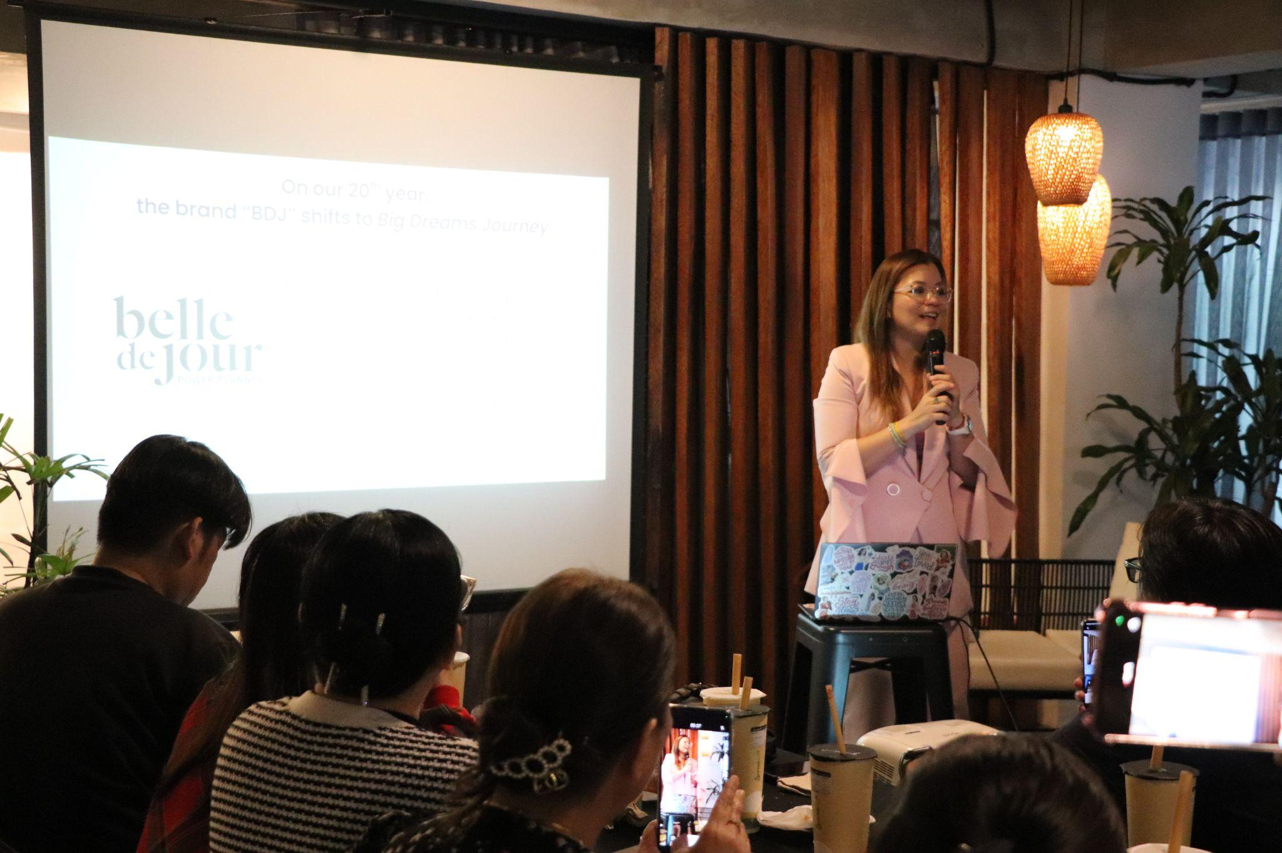
“We’re expanding what we’ve always stood for,” says Darlyn Ty-Nilo, founder of BDJ. “For 20 years, the planner has been our foundation. Now, we’re building on that legacy by offering more tools, more experiences, and more ways to help people live their dreams.”
This evolution introduces Big Dreams Journey—a Dreampowerment System built on three pillars: tools, workshops, and community. It begins with the Vision Board Kit, Dreampowerment Journals, and of course, the Planner, a trifecta designed to help dreamers move from vision to action and from inspiration to real-life transformation.
From its first planner launch to its annual BDJ Fairs, BDJ has become a cultural touchstone for a generation redefining ambition, self-worth, and what it means to live with intention. Over the years, it has grown to include vision boards, guided journals, affirmation decks, workshops, and Dreampowerment challenges, transforming the act of planning into a joyful, creative practice of designing one’s life.
“Every season of BDJ brought us closer to what we were truly meant to be: not just a planner brand, but a movement,” Ty-Nilo shares. “This 20th year marks an expansion and a reaffirmation of our mission to support dreamers in even more powerful ways.”
The 2026 BDJ 20th Edition serves as both a celebration and a springboard. It honors two decades of stories, milestones, and dreams, while introducing the next evolution of BDJ’s Dreampowerment tools for transformation.
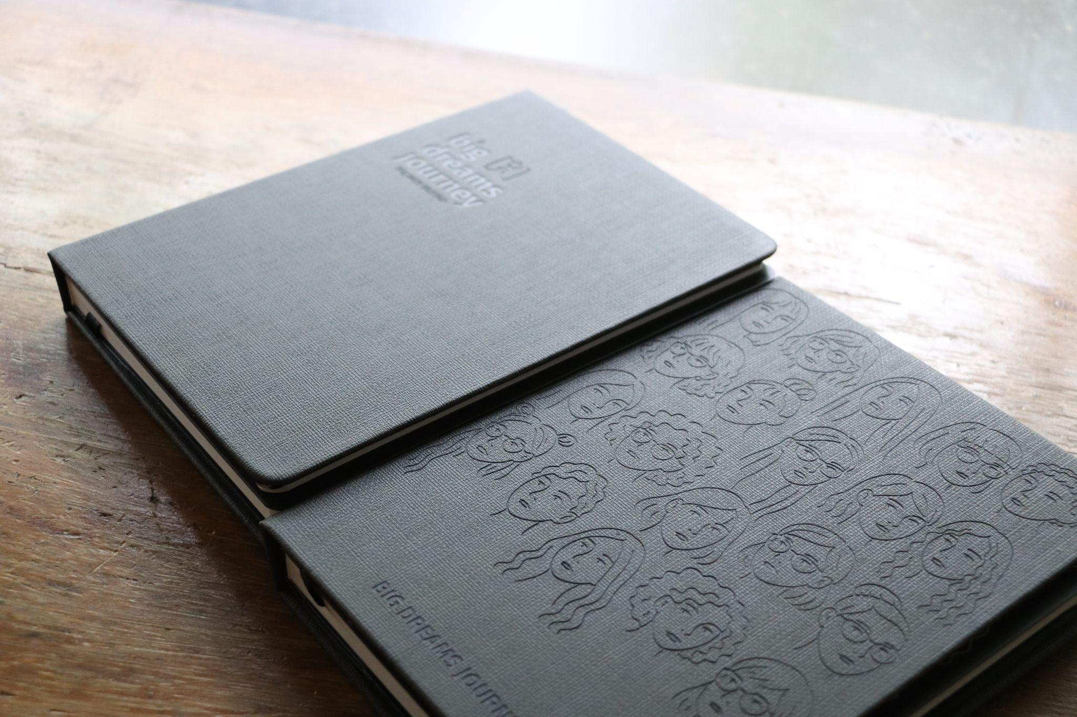
Big Dreams Journey will roll out new Dreampowerment experiences, from goal-setting challenges and community Spark Sessions to journaling and visioning workshops—all designed to turn reflection into action and dreams into reality.
“Dreams aren’t meant to be pursued alone,” Ty-Nilo adds. “They flourish in the community. That’s what Big Dreams Journey is all about: creating spaces where each person’s growth fuels another’s courage to dream.”
While the iconic planner steps off center stage to share the spotlight, BDJ’s mission continues stronger, wider, and more intentional than ever.
“If the first 20 years were about empowering people to plan their dreams,” Ty-Nilo concludes, “the next phase is about supporting them in truly living their dreams. Our North Star is no longer just putting out a planner year on year; we’re in the business of supporting dreams and taking action and steps towards them. That’s the legacy we want to carry forward.”
Big Dreams Journey represents BDJ’s evolution from product to purpose, a living empowerment ecosystem of tools, experiences, and connections that help everyone design the life they dream of.

Quick Facts
Founded: 2006
Founder: Darlyn Ty-Nilo
20th Anniversary Celebration: October 8, 2025 – The Astbury, Makati City
Brand Evolution: Big Dreams Journey
3 Pillars: Dreampowerment Tools, Workshops, Community
Flagship Tools: Vision Board Kit, Dreampowerment Journals, BDJ Planner
Community Experiences: Spark Sessions, Dreampowerment Challenges, Dreamers in Action
Website: shop.ilovebdj.com
Social Media: @ilovebdj
Brand Assets

For press inquiries, interviews, or promo materials:

Ian Emmanuel C. Urrutia
NYOU PUBLIC RELATION CONSULTANCY
Telegram or Viber: +63 956 591 3367
Email: ianurrutia@nyoumarketing.com

