Taguig schools to receive eco-friendly handwashing stations in support of Global Handwashing Day
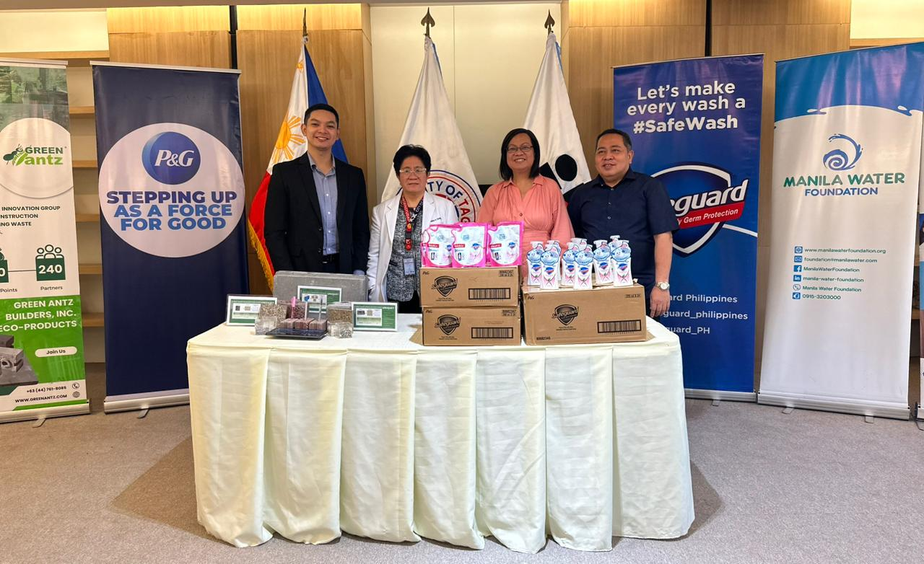
From left to right: P&G Philippines Corporate Communications Manager King Martin Agoncillo, Head of Taguig City Health Office Dr. Norena Osano, Taguig City Health Office Executive Assistant for Health Dr. Cecille Montales, and School Governance and Operations Division (SGOD) OIC Chief Dr. Roldan Jamindang

[Manila, Philippines]: In celebration of Global Handwashing Day, Procter & Gamble (P&G) Philippines, the multinational company behind the number 1 anti-bacterial soap in the Philippines Safeguard, is donating eco-friendly handwashing stations to 19 schools in Taguig City as part of its commitment to bringing health and hygiene to Filipinos across the country.

Global Handwashing Day is celebrated every year, on October 15, which aims to promote the importance of proper handwashing with soap as an easy and effective way to prevent the spread of germs and keep communities safe from diseases.

This initiative is part of P&G's #SafeWASH program in collaboration with Manila Water Foundation, which aims to strengthen efforts to promote the importance of proper handwashing with soap and water in schools. The project underscores the significance of WASH (water, sanitation, and hygiene) in schools, a commitment at the core of the joint project between the two organizations. The eco-friendly handwashing stations will be constructed in partnership with Green Antz Builders using eco-bricks, which are made by turning plastic waste into durable building blocks.

“These eco-friendly handwashing stations will promote proper WASH habits that will help protect students and teachers from disease-causing bacteria and viruses while also championing sustainability, says King Martin Agoncillo, Corporate Communications Manager at P&G Philippines.

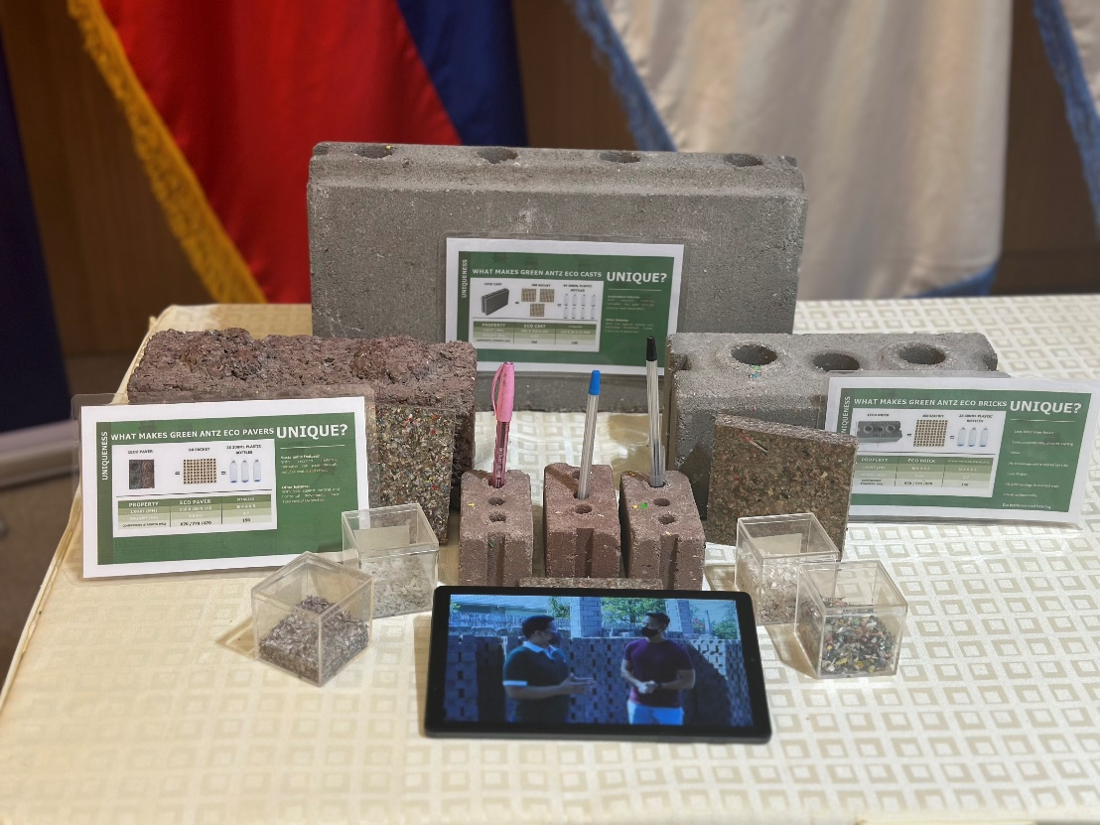
Sample eco-bricks that will be used to construct the 19 eco-friendly handwashing stations.

In another Global Handwashing Day Celebration, P&G supported Pasig LGU’s "Apir Tayo, Pasigueno! Global Handwashing Day Fair 2023" in partnership with Manila Water Foundation, benefitting over 1,000 Pasiguenos, including PWDs, 4Ps beneficiaries, Muslim market vendors, enforcers, and health workers.

P&G has been a consistent partner of MWF since 2020 in providing students with quality handwashing facilities; promoting health and hygiene through good handwashing practices. The partnership has since constructed 285 handwashing stations, reaching over 1 million students, teachers, and other school staff in over 285 schools in Metro Manila.
###
About Procter & Gamble
P&G serves consumers around the world with one of the strongest portfolios of trusted, quality, leadership brands. Fostering equality and inclusion, supporting our communities and protecting the planet are embedded in how we do business. We believe we have a responsibility to make the world better — through the products we create and the positive impact our brands and Company can have. P&G’s portfolio includes Always®, Ambi Pur®, Ariel®, Bounty®, Charmin®, Crest®, Dawn®, Downy®, Fairy®, Febreze®, Gain®, Gillette®, Head & Shoulders®, Lenor®, Olay®, Oral-B®, Pampers®, Pantene®, SK-II®, Tide®, Vicks®, and Whisper®. The P&G community includes operations in approximately 70 countries worldwide.

Please visit http://www.pg.com for the latest news and information about P&G and its brands.

Media Contacts:

Procter & Gamble Philippines Evident Integrated Marketing and PR
King Martin Agoncillo Melissa Monico
agoncillo.ku@pg.com m.monico@evident.ph

