Shopee announces biggest brands sale of the year with the 10.10 Brands Festival
Look forward to mas mura brand deals up to 50% off, back-to-back Super Brand Days, and new brand ambassador Toni Gonzaga at the 10.10 Brands Festival from October 1 to 12
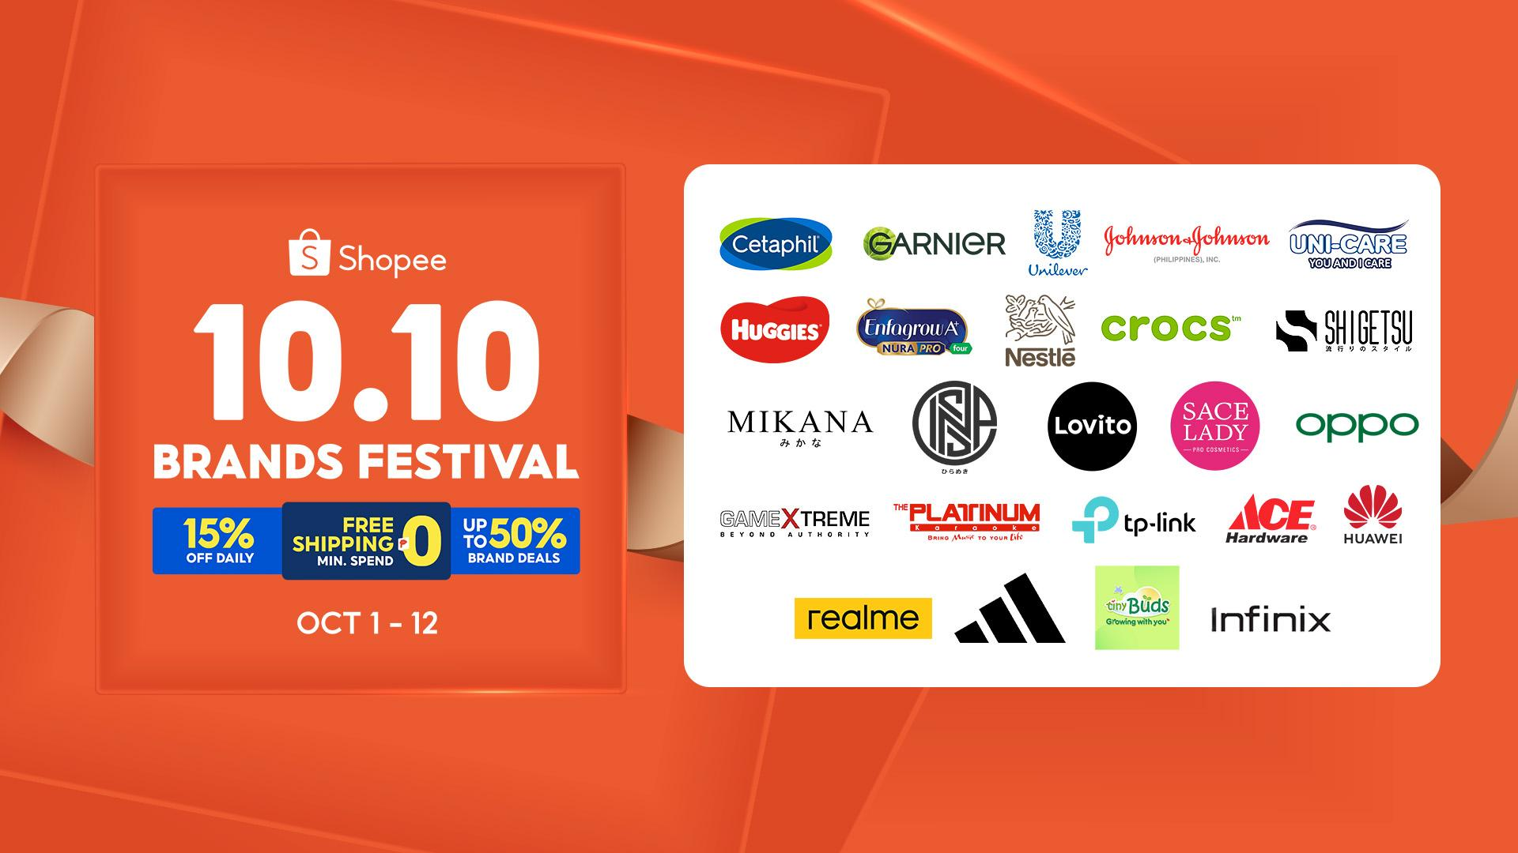
MANILA, SEPTEMBER 29, 2022 - Shopee is collaborating with the country’s leading brands to bring Filipinos bigger, better, and mas mura deals on brand favorites with the 10.10 Brands Festival. From October 1 to 12, official brand stores are working with Shopee to offer eager shoppers 50% off brand deals, 15% off daily discounts, and free shipping vouchers with no minimum spend.
The 10.10 Brands Festival is the second in Shopee’s series of year-end shopping events, giving Filipinos more exciting deals to look forward to and get a head start on their holiday shopping. Martin Yu, Director at Shopee Philippines enthused, “The 10.10 Brands Festival continues to enliven the promise of offering mas mura prices to Filipino shoppers. We have worked closely with our partner brands in bringing the best of brand deals to create a more meaningful year-end shopping experience.”

Toni Gonzaga joins the Shopee Fam as newest brand ambassador

To drum up anticipation for its 10.10 sale, Shopee welcomes Toni Gonzaga as their newest brand ambassador. Dubbed the Ultimate Multimedia Star, shoppers can look forward to watching the talented performer belt out the “Mas Mura sa Shopee” jingle as she stars in Shopee’s latest TV commercial. Fans will also be treated to entertaining content when they visit the app and Shopee’s official accounts on Facebook, TikTok, Twitter, Instagram and YouTube.
Exciting, mas mura brand deals from October 1 to 12
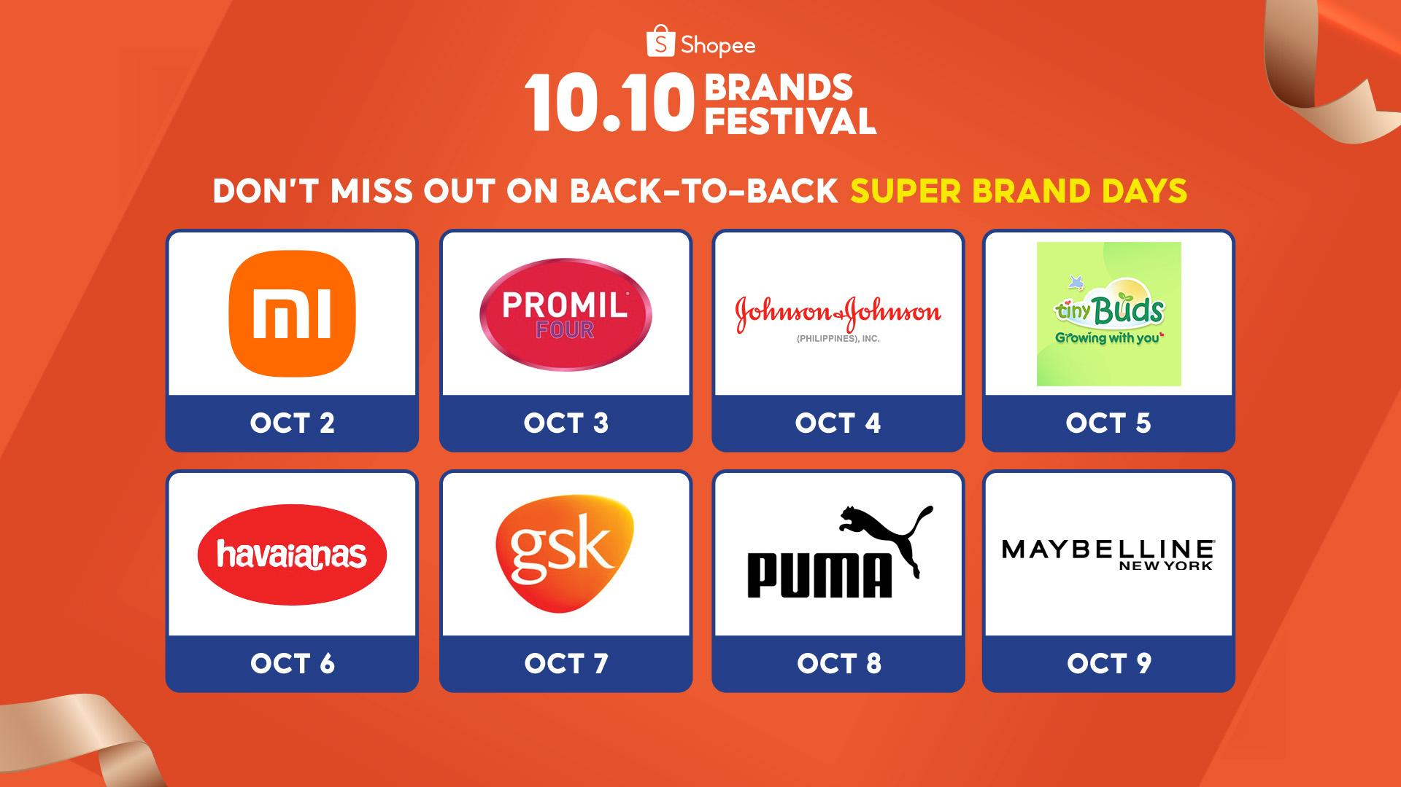
The 10.10 festivities begin as early as October 1, with a wide assortment of official brand stores on Shopee offering exciting discounts for shoppers. The sale kicks off with back-to-back Super Brand Days from October 2 to 9, where users can enjoy up to 50% off on products from leading brands in fashion, electronics, beauty, and home & family essentials.
Unbeatable offers from top brands also await early-bird shoppers with the Big Midnight Sale from 12 midnight to 2 AM on October 10. Users can get a jumpstart on their holiday shopping with limited deals on bestselling wearable devices like the Samsung Galaxy Buds Live and OPPO Band B1, as well as trendy fashion and lifestyle items such as the Crocs Crocband™ Flip and Insulated Water Bottle from the widely popular brand Aquaflask.
Shoppers can also expect more exciting deals from other leading brands including: Tiny Buds, realme, Platinum Karaoke, INSPI, Johnson & Johnson, Huggies Philippines, Uni-Care, Cetaphil, Garnier, Unilever, Enfagrow, Nestlé, Lovito, SACE LADY, adidas, Infinix, GameXtreme, TP-Link, Ace Hardware, and Huawei.

The Big Midnight Sale also allows new parents to enjoy big savings with ₱1 deals on these Pampers Baby Dry Taped Diapers. Meanwhile, beauty lovers can score fan favorites like the Maybelline Superstay Matte Ink Liquid Lipstick and this Issy & Co. Brow Refiner, both at 50% off.
Download the Shopee app and discover mas mura deals from leading brands at the 10.10 Brands Festival. Head on to Shopee’s 10.10 page to know more about the latest promos or share your memorable 10.10 moments with the hashtag #ShopeePH1010BrandsFestival.
- END -
About Shopee
Shopee is the leading e-commerce platform in Southeast Asia & Taiwan. Shopee promotes an inclusive and sustainable digital ecosystem by enabling businesses to digitalize and grow their online presence, helping more people access and benefit from digital services, and uplifting local communities.
Shopee offers an easy, secure, and engaging experience that is enjoyed by millions of people daily. Shopee is also a key contributor to the region’s digital economy with a firm commitment to helping homegrown brands and entrepreneurs succeed in e-commerce.
Shopee is part of Sea Limited (NYSE: SE), a leading global consumer internet company. Sea’s mission is to better the lives of consumers and small businesses with technology through its three core businesses: Shopee, Garena and SeaMoney.

